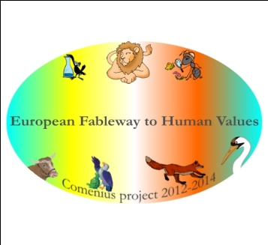Romanian Maths Problems

In a natural reservation there are 7 lions and a few eagles. We know that the total number of feet of lions and eagles is 110. How many eagles are there?

- A dog had a cage on a square surface with a side of 2 m. Calculate the surface area.

- The dogs Samurache and Samson have both a bowl with bones. Samurache has 10 bones more than Samson. The total number of bones is 2000. How many bones does each dog have?

- A magpie has $\sqrt{100}$ eggs. An ox ate $\sqrt{25}$ of her eggs. How many eggs does the magpie have now?

- The dog and the puppy wanted to have a running competition on 100 m. The puppy ran 25 m and the dog ran 50 m. What is the distance covered by the dogs?

- The dog has hidden 3 times more bones than the puppy. The puppy had $3\sqrt{25}$ bones. How many bones did the dog have?

- In the yard there were 30 hens. The hawk stole $\frac{2}{3}$ of all hens. How many hens are there in the yard now?

- At Samson’s shop, a fish costs €5. The price increased with 20% and decreased with 5%. How much is the fish now?

