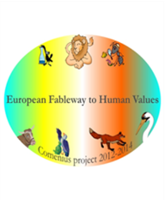

The lion and the mouse

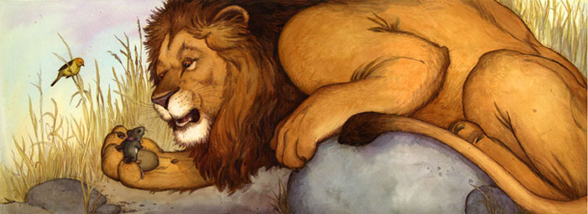The lion wants to eat the mouse. The mouse says: “But I am only 250gr. You are 1250 times heavier than me. Please, don’t eat me.” How much does the lion weigh?

The stork and the fox

The stork invited the fox for dinner. He wanted to cook a soup and a cake.

For the soup he needed 2/9kg carrots, 1/4kg potatoes, 1/3kg tomatoes, and 1/6kg broccoli.

For the cake he needed 1/25kg butter, 1/8kg cream, 3/25kg chocolate, 1/10kg nuts.

1. How many kg of vegetables will he need for the soup?
2. How many kg of other ingredients will he need for the cake?

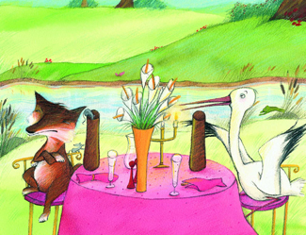

The lion, the king of the forest

The lion, the king of the forest, was eating small animals, every time he was hungry. In May and June the lion ate 105 animals. In May, he ate 35 animals more than in June. What is the percentage of the animals he ate in May and June?

