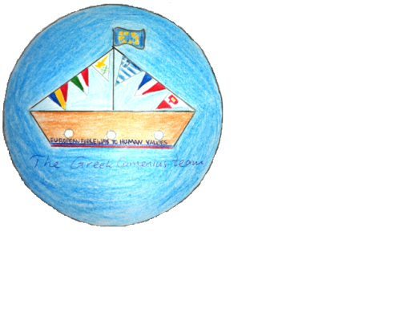

**FABLE MATHS PROBLEMS FROM THE GREEK COMENIUS TEAM**

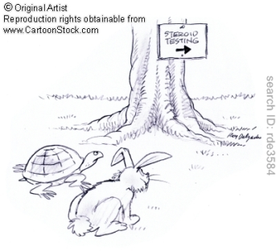

**The street race of the hare and the tortoise**

The hare and the tortoise decidedto have a street race to find out

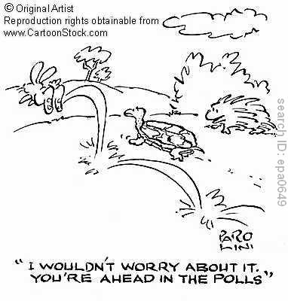which of them runs faster!!!

The hare estimated that with 60 leaps of 5m, he could cover

the distance the fox had arranged for them to run.

After making 15 leaps quickly, he decided to take a little rest.

You see, the tortoise was still too far behind, since every step

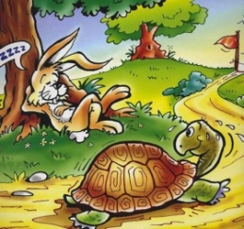 she took was only 10cm long.

But when he woke up and went on with the race, he didn’t meet the tortoise

at all. To his great surprise, when he came closer to the finish line,

he saw she had already passed the finish line and had won the race!

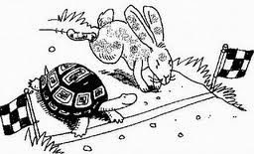 Ι)How long was the distance they had to cover?

ΙΙ) How many steps did the tortoise take to reach the finish line?

ΙΙΙ) What part of the hare’s leap was the tortoise’s step?

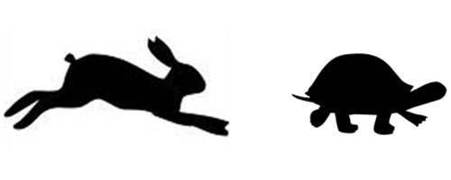

( From Comenius math teachers for the younger pupills)

**The heron and the fish and the crawfish**

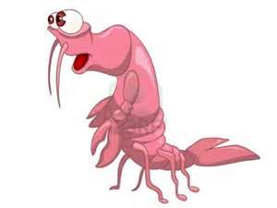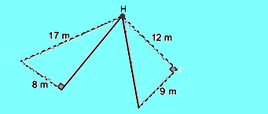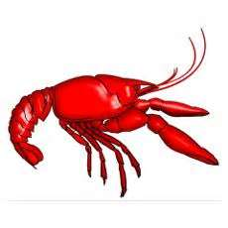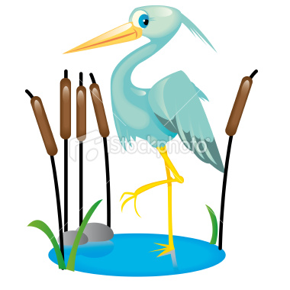

Which is nearer to the heron

the crawfish or the fish?

(Year 2 Junior High School Maths book exercise, modified for the Polish Comenius team’s fable ‘Heron, fish and crawfish’)

**The sailing boat**



In a sailing boat the height of the mast to point A is 8m.

Can you estimate the length of the rope which hold the

Sails if they form angles of 55⁰ and 70⁰ respectively with

the sea level?

(Year 2 Junior High School Maths book exercise)

**The fox and the crab**

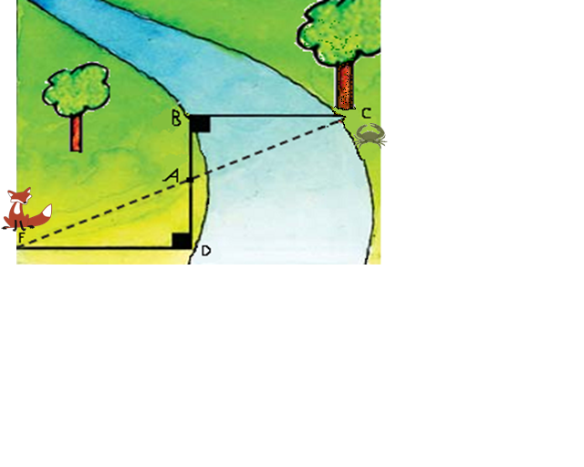

A fox saw a crab to coming out of the water and thought that it would be a good idea to go to the opposite side of the river to be near the tasty food.

Can you find how many meters is the length **BC** of the bridge, that the fox has to cross, if we know that **AB=12m** , **AD=28.8m** , **FD=60m** και .

(Year 3 Junior High School Maths book exercise, modified for the Greek Comenius team’s fable ‘The fox and the crab’)

**The Raven and the Fox**

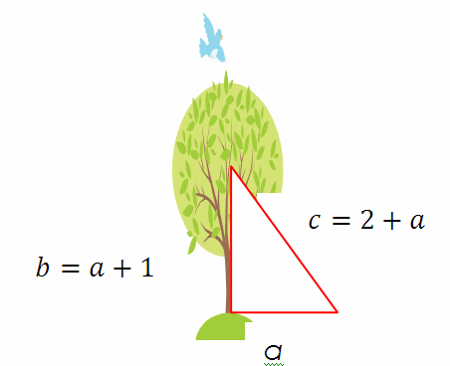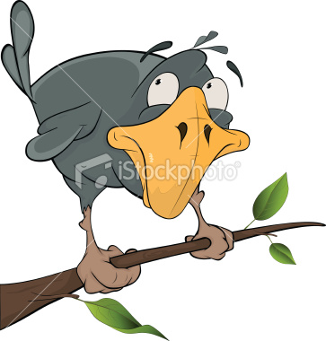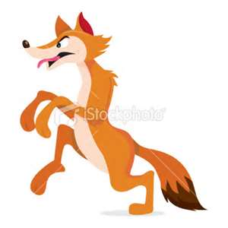

How far from the trunk of the tree is the fox gazing at the raven

who is holding a piece of chease in his peak?

( From Comenius math teachers for the eldest pupils )